`
Vulcan Activity Tracker
Weekly Report

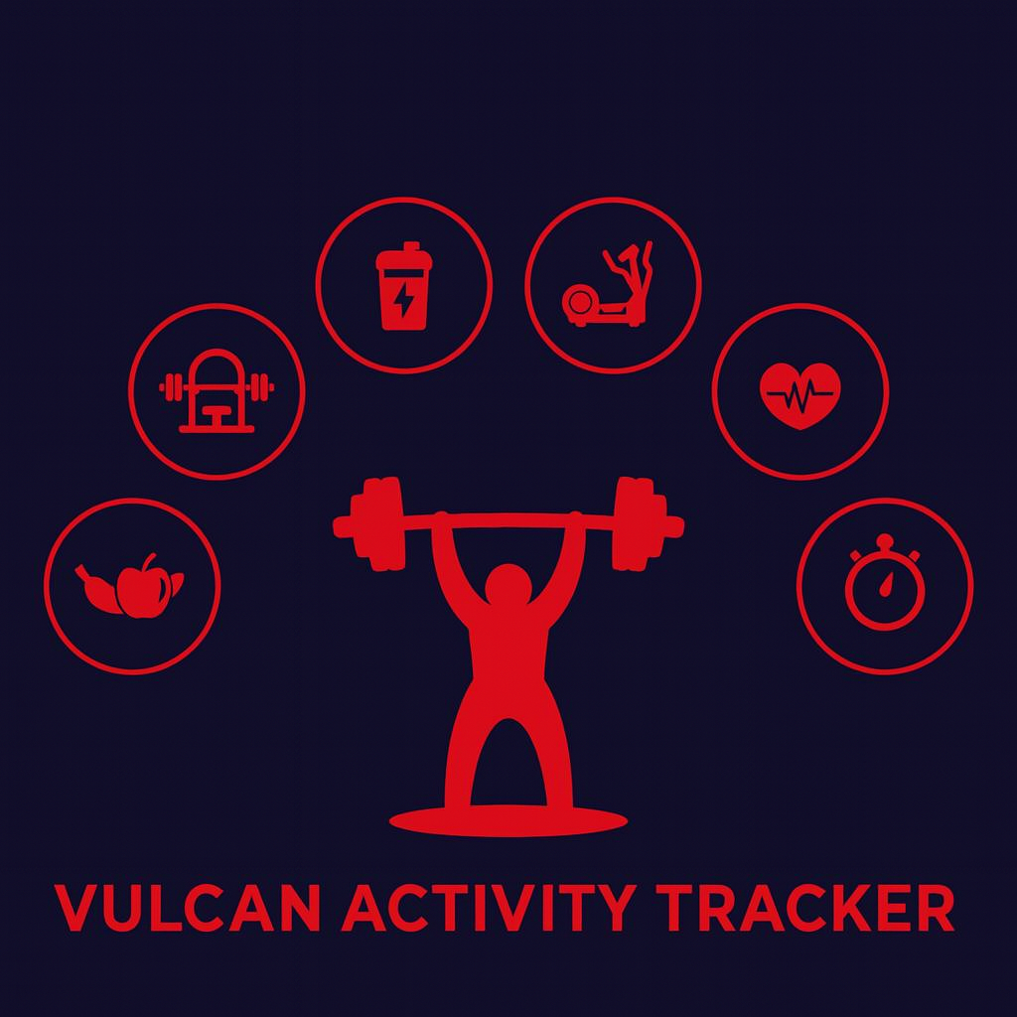

Week 9
Team Members:
Margo Bonal
John Gerega
Luke Ruffing

Professor: Dr. Weifeng Chen

Course: CMSC-4920-Senior Project II
School: Pennsylvania Western University

Table of Contents

Project: Vulcan Activity Tracker 2
Goals Accomplished: 2
Challenges Faced: 3
Team Progress: 4
Gantt Chart: 5
Week 10 Plan: 5
Member Contribution: 6
References 6

Project: Vulcan Activity Tracker
To complete the proposed goals in previous week’s report, our team followed a strict schedule of daily progress and communication even though week 8 is designated as Spring Break. Our team had 4 main goals to complete, which included implementing a feature that allows users to receive an email to verify their account or recover their password, adding a user profile section that allows a user to delete their account or update their username, and continuing development of both the challenges and team’s page. Additional goals included continued development of the maps page and finalization of the dashboard. Since each goal needed time allocation for development and testing, we assigned each goal priority based on how they were connected to each other. Throughout the discussion, we decided that not allowing access to the tracker before a user is properly logged in was the main goal of this week. Achieving this goal will help keep the privacy of our tracker.

Goals Accomplished:
The first goal accomplished was implementing a user profile section that allows users to delete their accounts and update their usernames. This section simply shows two buttons at the moment, which are buttons to delete the account and change the username. The next steps are to format the page to be more user-friendly, but getting those two functions to work correctly helped us take a huge step forward
The second goal accomplished was enhanced features on the map page. The maps page now includes a weather section that shows the user the current weather around campus. A user now has the ability to delete a route that they no longer want stored. A dynamic UI system has been implemented to show the delete button upon hover. This keeps the user interface clean. Additionally, our team visited the campus gymnasium to retrieve mapped and predetermined Vulcan running paths. We used this data to enter in our Vulcan Activity Tracker official campus routes. Our map feature is now complete and aligns our app with campus information for students to enjoy a cohesive experience.
The third goal was to get emails to send out, but we ran into a stumbling block when trying to do this. Continued research was done to find an email hosting system that would meet our platform needs.

Challenges Faced:
(Number aligns with its solution below)
- Resend Application policies – we had successfully gotten our code to the point where we could send the email to the users to recover their password. However, the error we were getting was that we needed to verify the pennwest.edu domain with DNS records that we do not have access to. So, we had to go looking for a new application to use, which put us back to step 1 in this journey to send emails.
- User Profile Functions – Both functions caused problems when trying to implement them. First, there was the delete account feature, which would not work until we cleared all foreign key references before deleting the user from our user table. The username change was causing an issue where, when the username was changed, their data would no longer be available to view.
- Solutions:
1. We found a new application called Dashboard. This application gives us 100 free emails per day in the trial plan, which does not require us to verify our domain. This could cause issues in the future if we have a large number of users, but for testing purposes, it is very helpful. We are now working to fit the dashboard API into our code in order to send an email with that key instead of the Resend key we attempted to use beforehand. However, an additional error was found. The email API key only works for the user that created the email API account. This causes our other team members to not be able to use the API. Since the email verification determines login success, without the code working it blocked team members from entering the platform for development. The email code was removed from the main working branch and saved on a separate branch of code until further development and research has been performed.
2. The User Delete function was an easy fix. We had to make sure we deleted the UserID column in each table that it was referenced. Once we did that, we could delete the UserID in the User table with no issue. Now the user can delete their account, and they will be returned to the main page of the application, With the username function, we were not updating the current user logged in correctly, so the application was still working on the assumption of their old username, so we had to update the current username to the newly updated username. Once we did this, we had no issues and the user’s data was successfully transferred to be associated with their new username.

Team Progress:
Throughout week 8 our team has made substantial progress to the Vulcan Activity Tracker. According to our Gantt chart our team is still on schedule for many parts of the project. It was very important to our team to leave spring break with thorough development on our senior project platform. We feel that we are on track, if not ahead of development progress. Each member provided valuable and crucial development, research, and debugging during this week.

Gantt Chart:
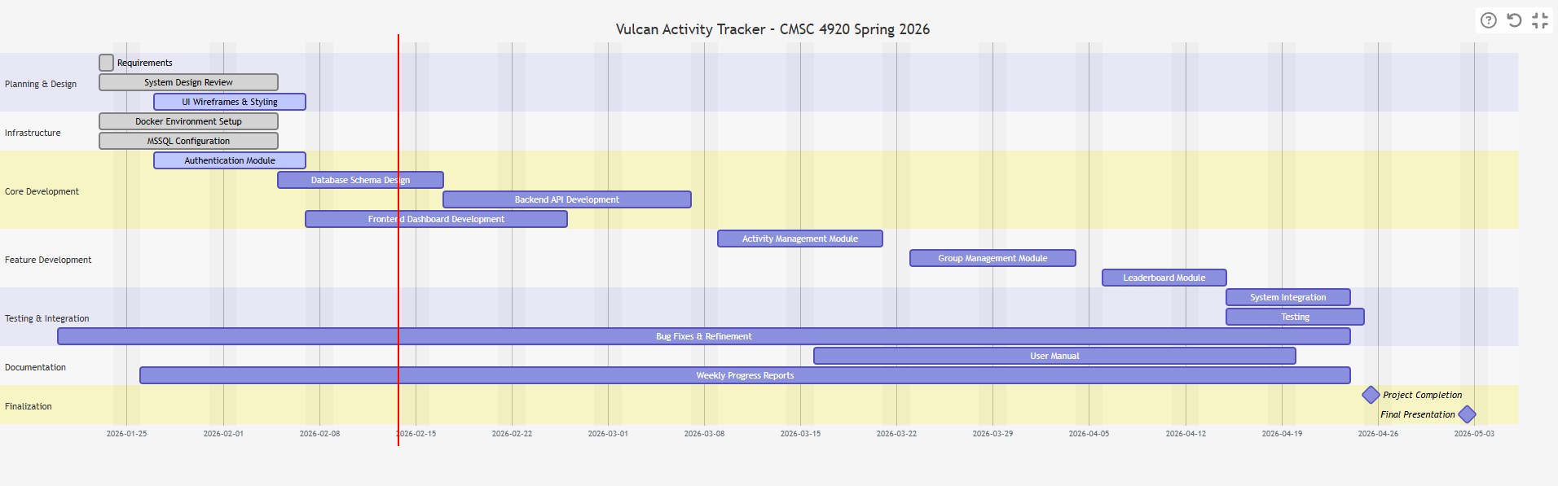

Week 10 Plan:
Our week 10 plan is going to focus on getting these recovery emails up and working. We also want to continue to improve the pages that are developed, with some of them still having minor bugs in them. The final goal of the week will be continuing development on the Teams page. Continuous checks also will be performed to ensure that our project is properly aligned with last semester’s documentation. With less than 6 weeks left of Senior Spring semester, our team moves forward with motivation to finalize features, add remaining components, and begin the platform hosting process!

Member Contribution:

Team Members
Margo Bonal: | - Team meetings, Week 8 Report & Slides, Maps page features, dashboard finalization
John Gerega: | - Team meetings, Week 8 Report & Slides, Teams page, Password recovery, research
Luke Ruffing: | - Team meeting, Week 8 Report & Slides, Challenges page

References

OpenWeather. (2026). OpenWeatherMap.
https://openweathermap.org/api

